**5.1 Learning Objectives**

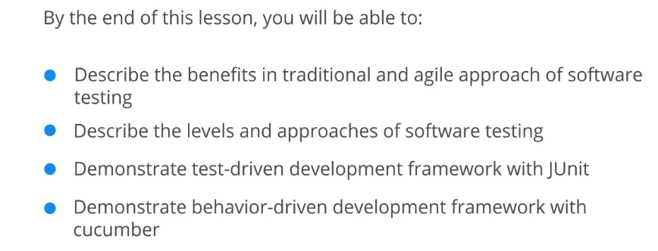

**5.2 Software Testing Overview**

Software Testing:

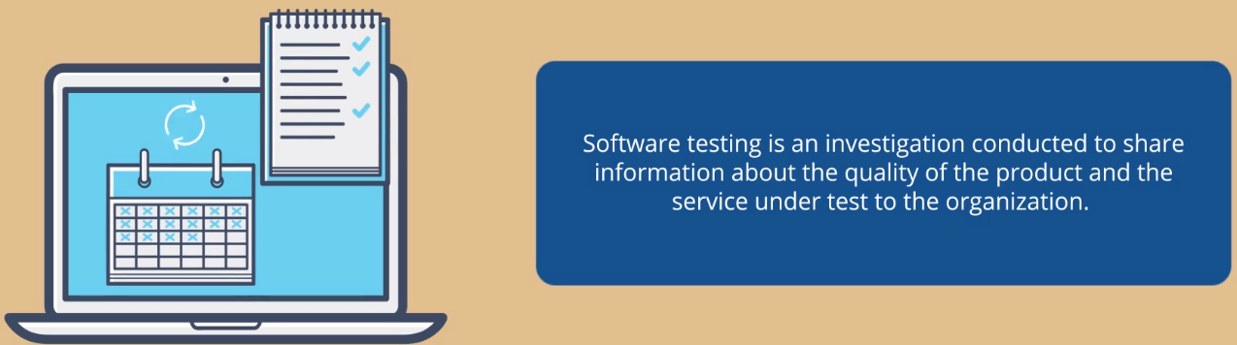

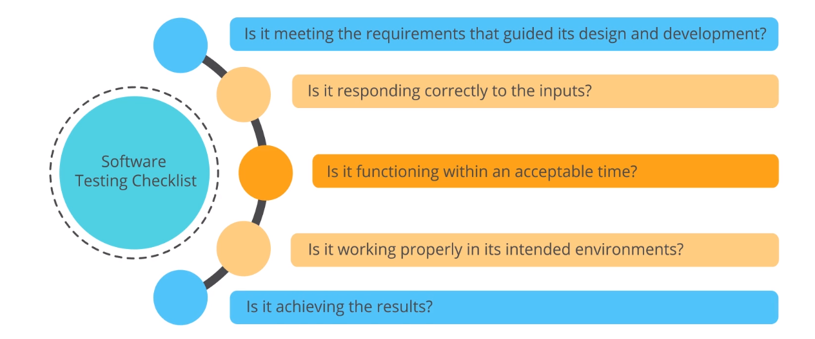

Tradional vs. Agile Testing:

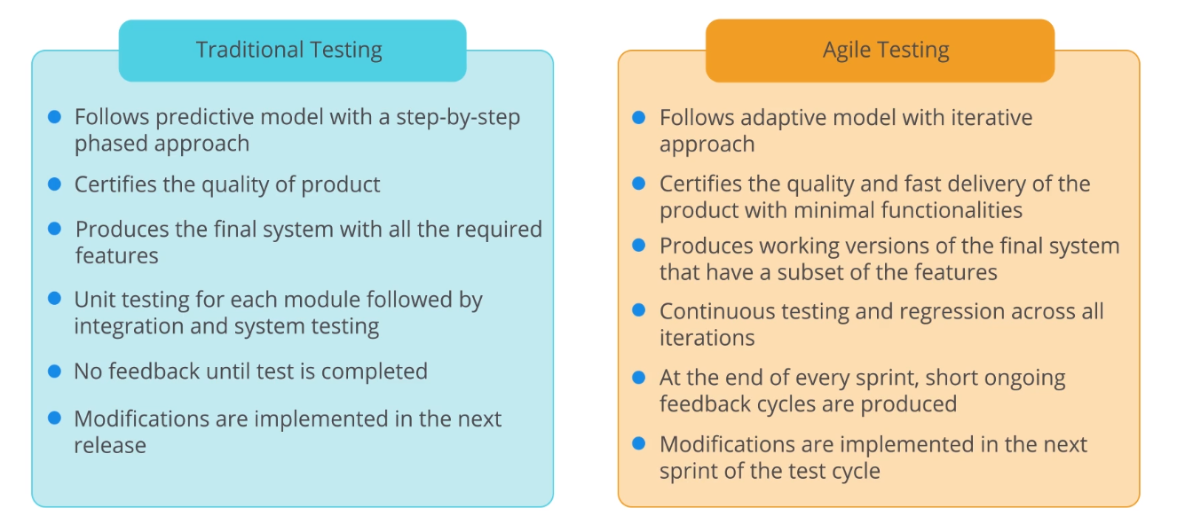

Agile Testing Advantages:

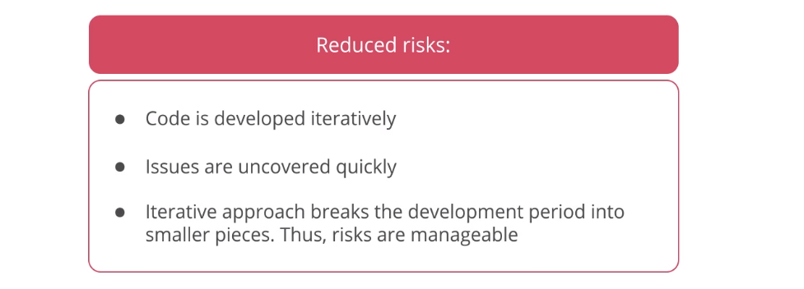

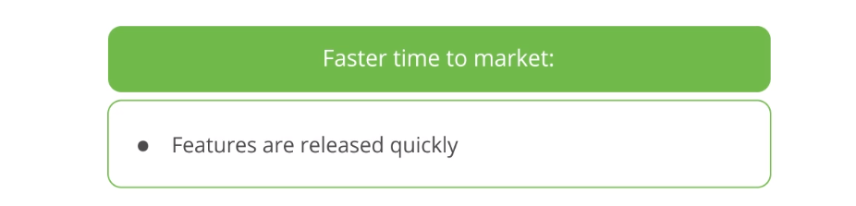

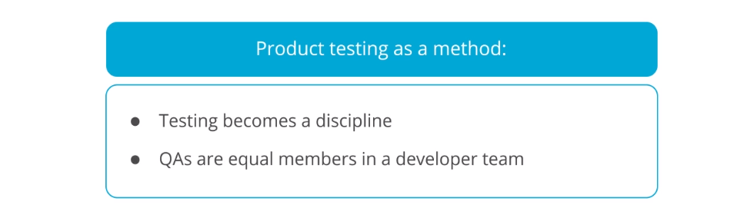

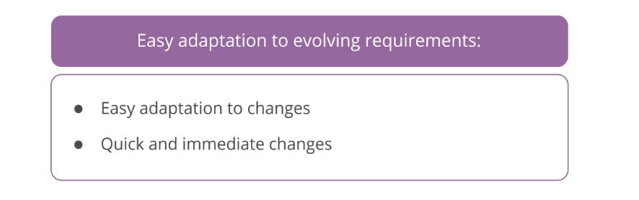

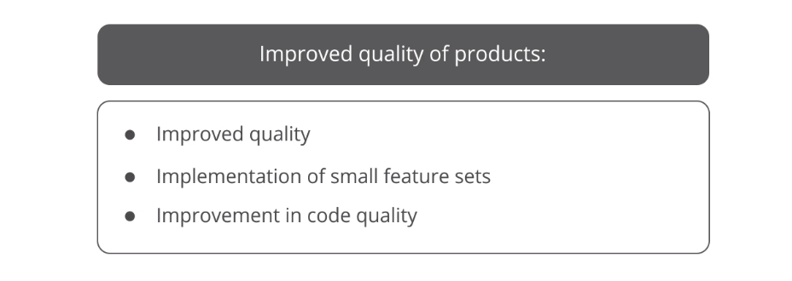

Advantages of Using Agile with DevOps Testing:

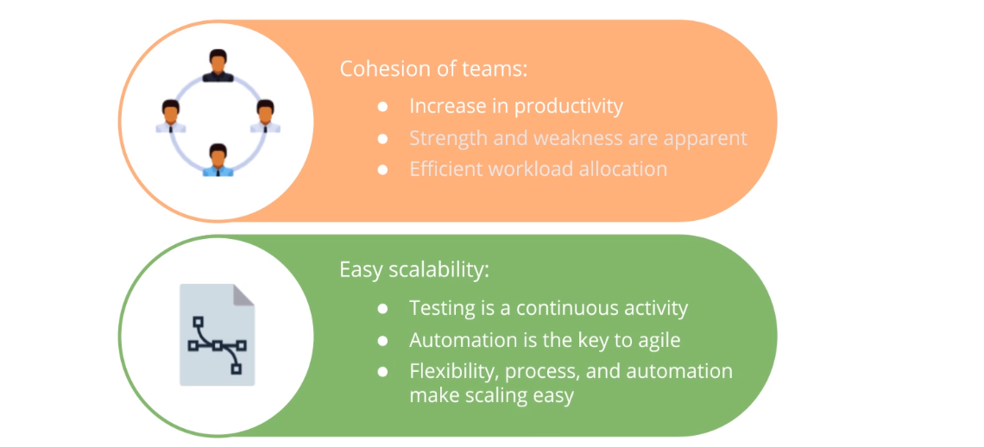

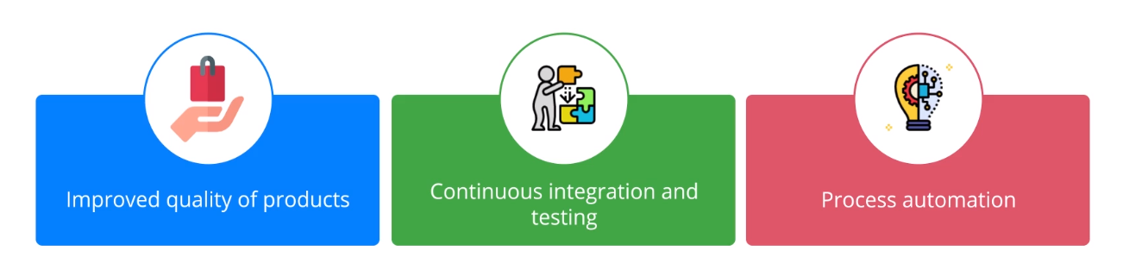

**5.3 Testing Levels Approaches and Automation Tools**

Software Testing Approaches:

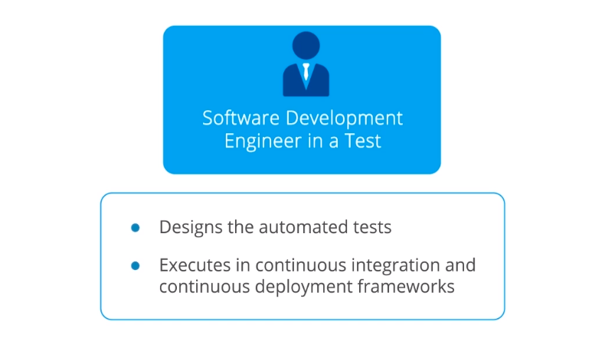



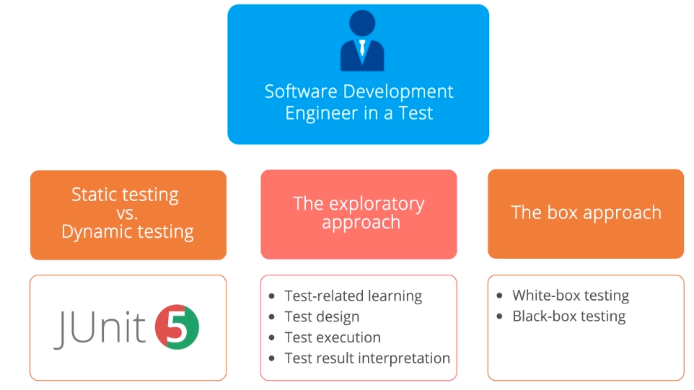

Software Testing Levels:

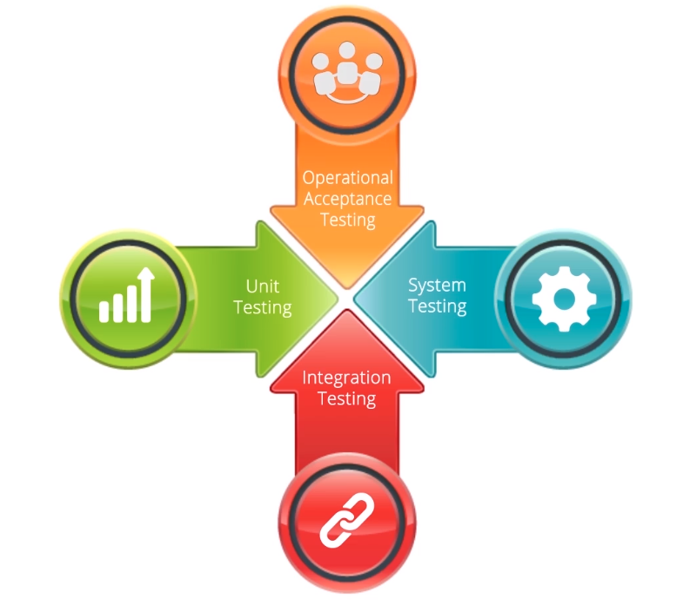

Popular Software Testing Techniques:

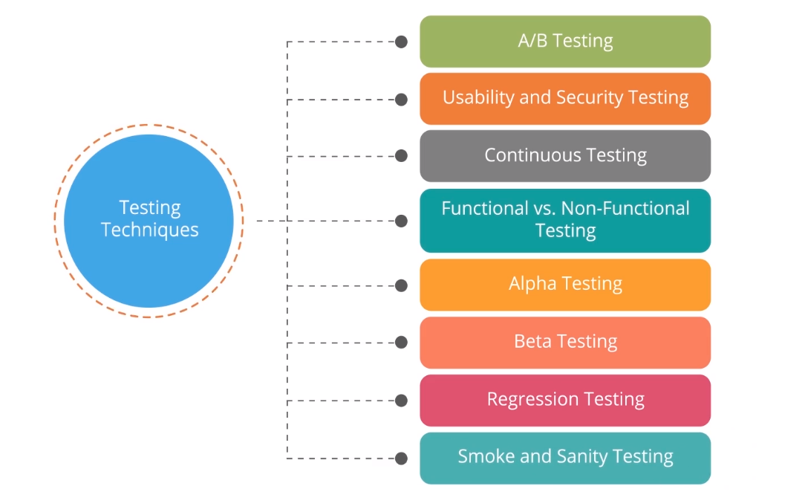

A/B Testing:

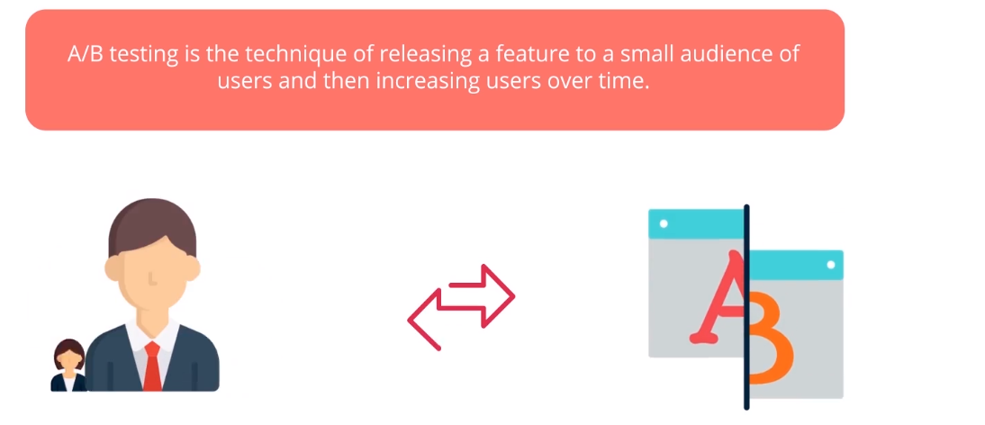

Usability and Security Testing:

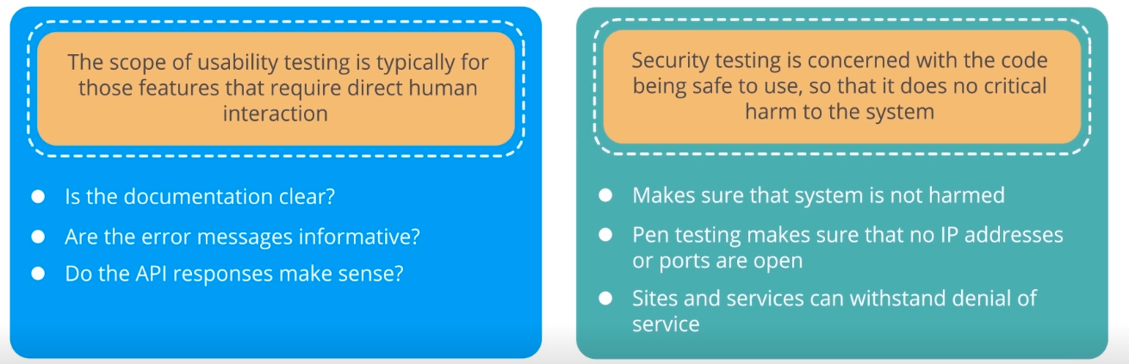

Continuous Testing:

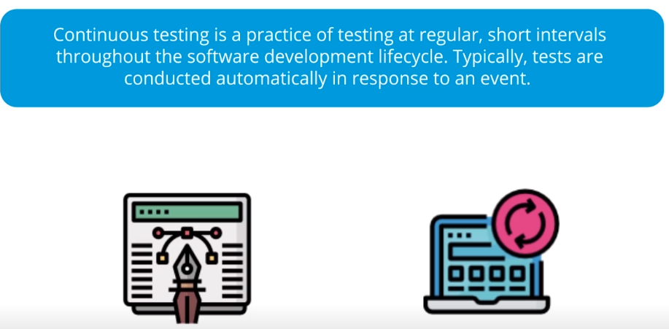

Functional vs. Non-Functional Testing:

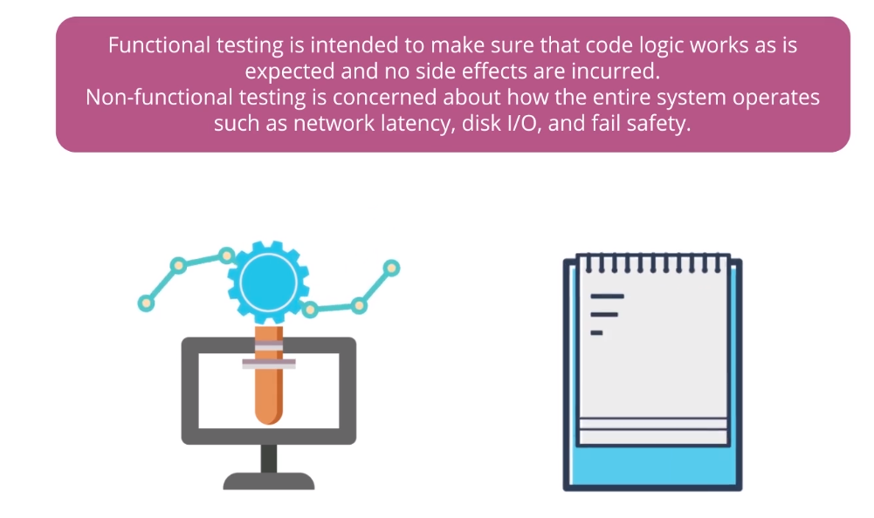

Alpha and Beta Testing:

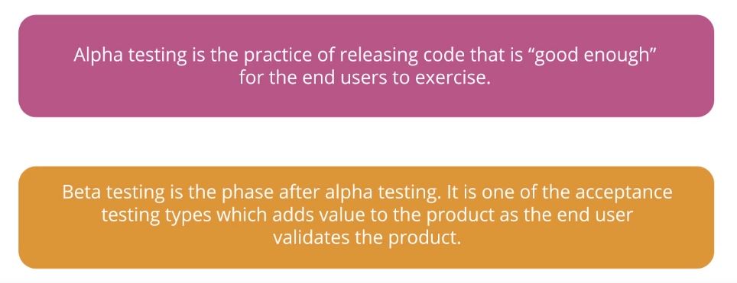

Regression Testing:

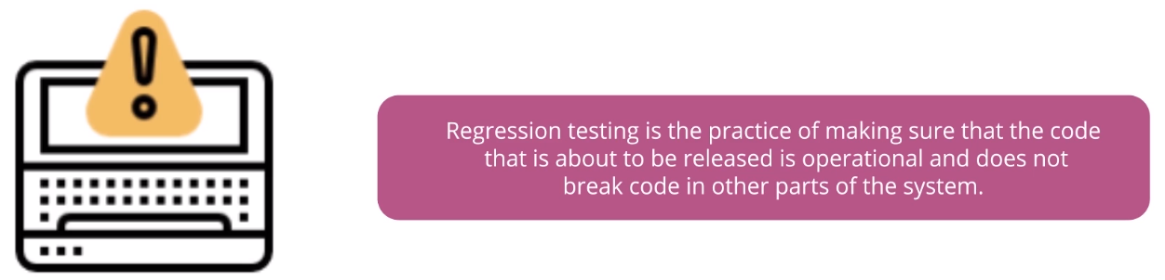

Smoke and Sanity Testing:

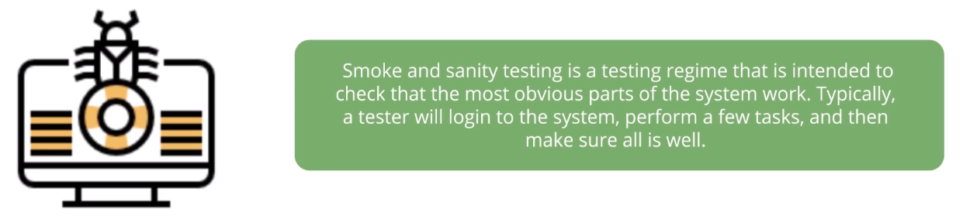

Automation Testing Frameworks:

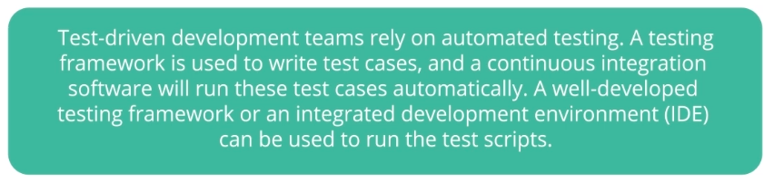

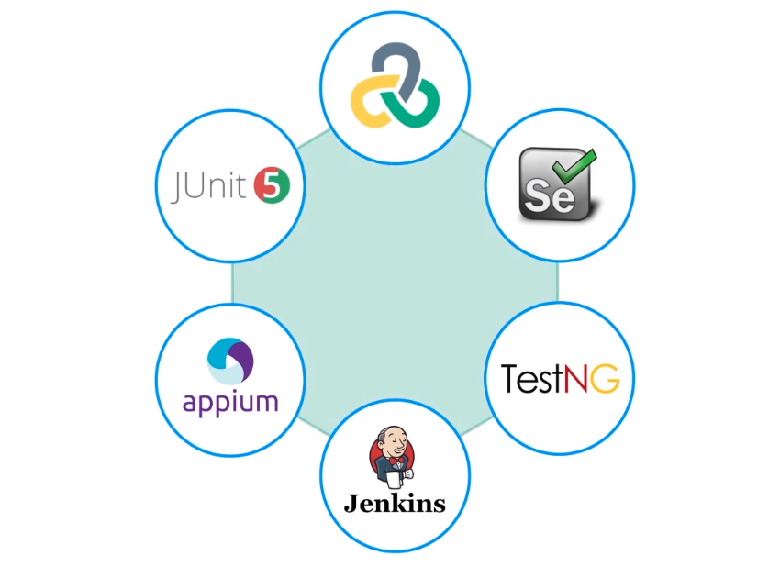

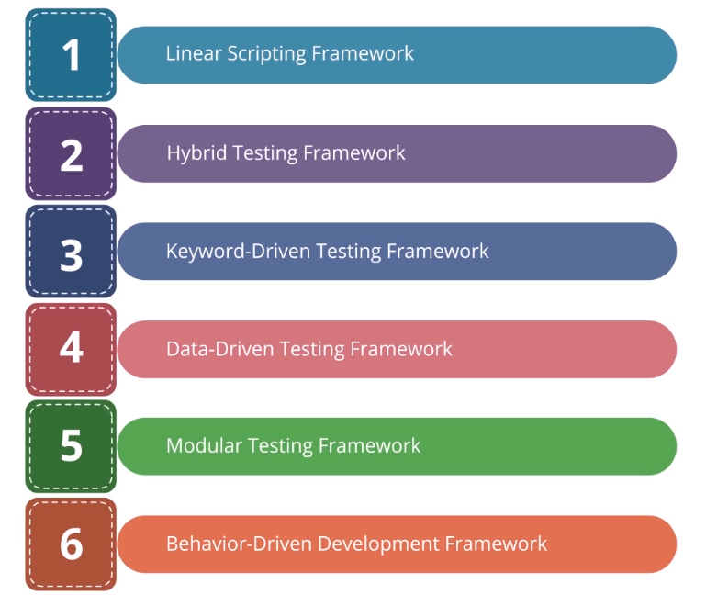

Popular Testing Tools:

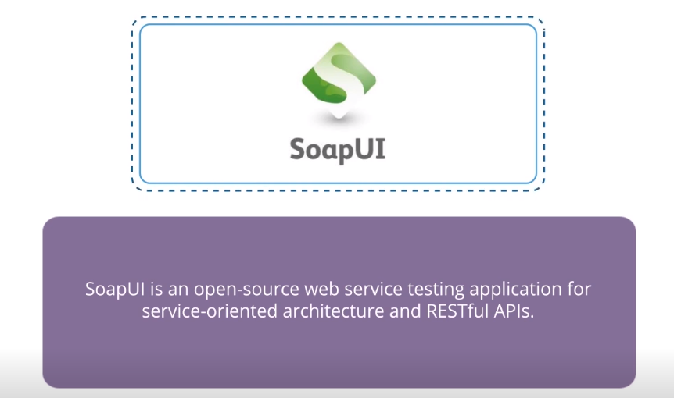

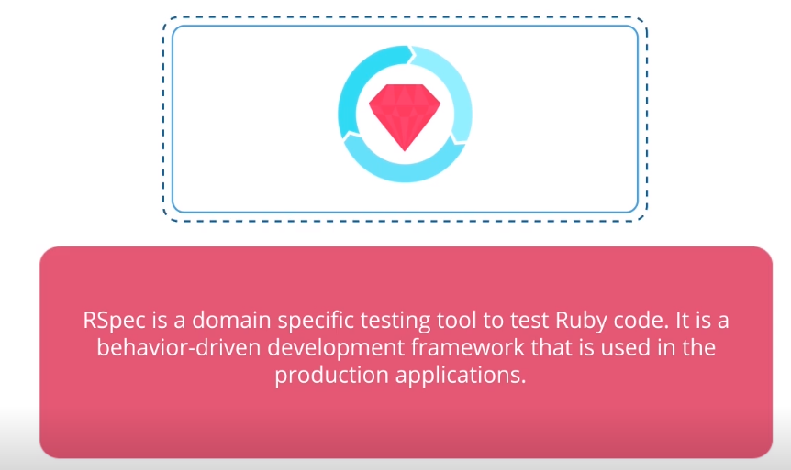

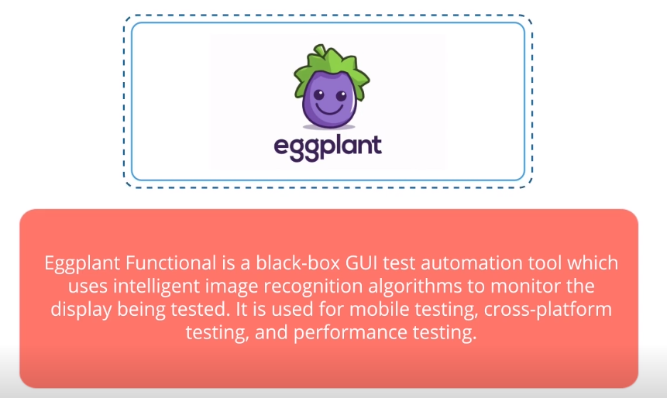

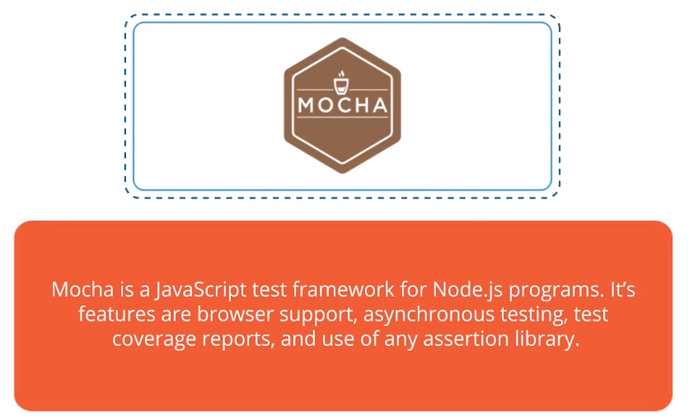

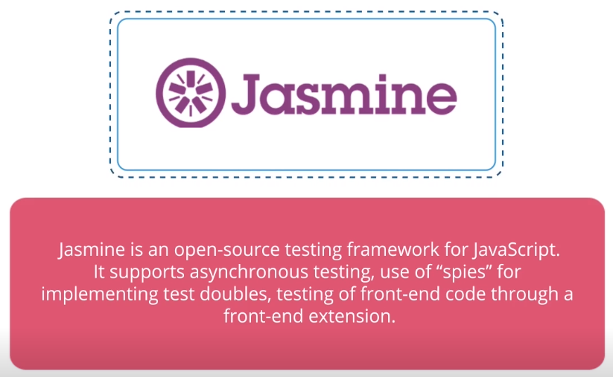

**5.4 Test-Driven Development Approaches and JUnit Five**

Overview of Test-Driven Development:

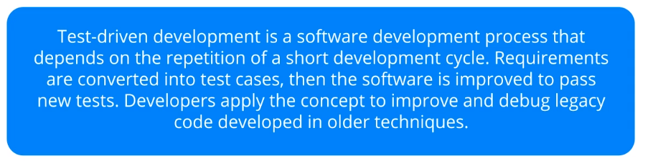

Test-Driven Development Cycle:

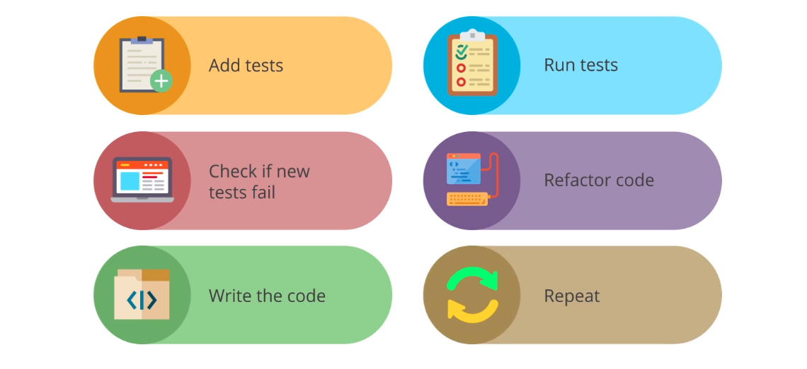

Test-Driven Development Advantages:

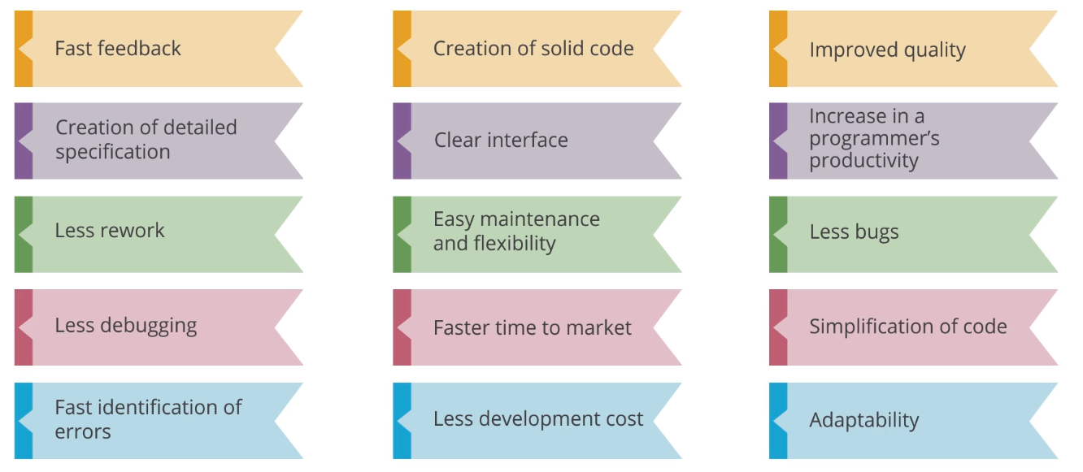

Overview of JUnit:

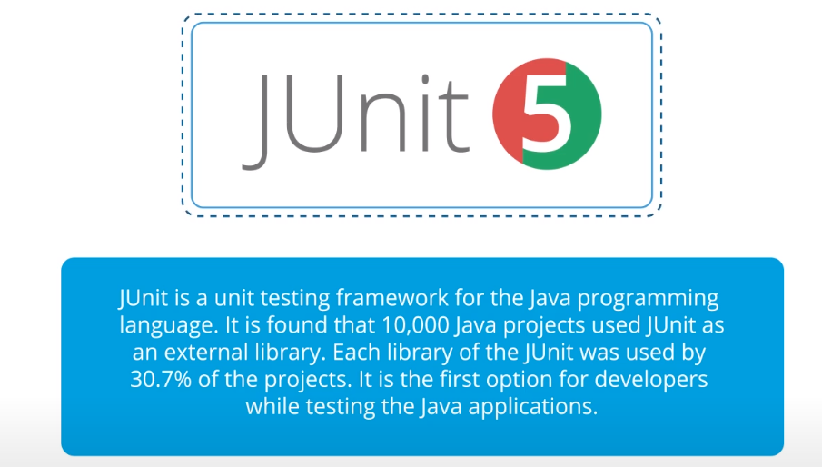

Advantages of JUnit:

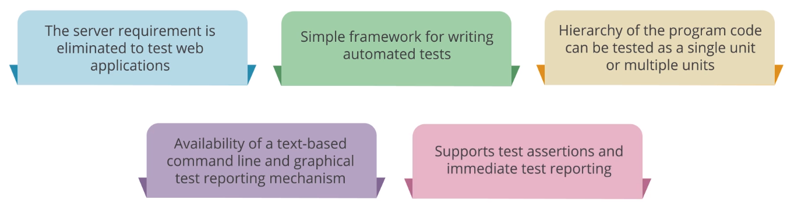

Java Programming Language:

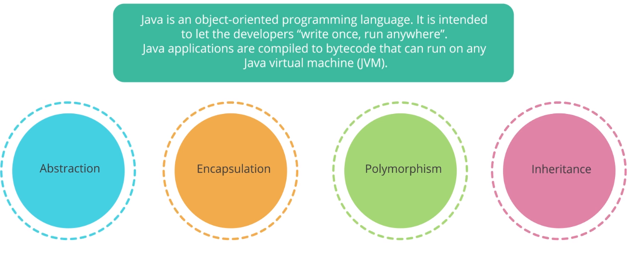

JUnit5 with Java

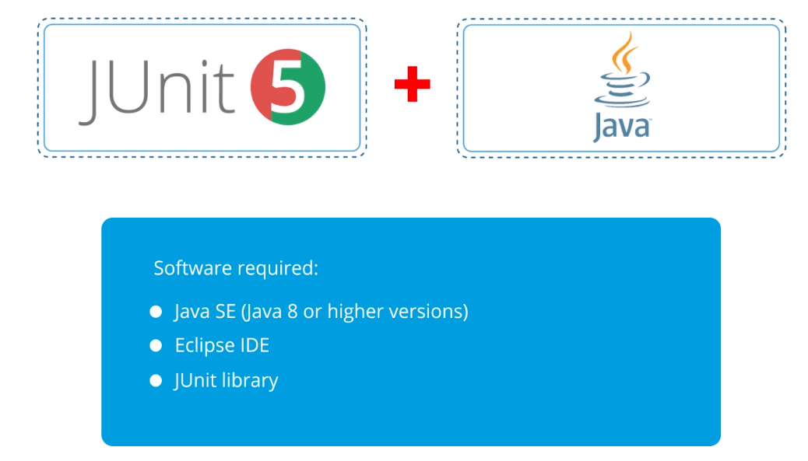

**5.5 Test-Driven Development Approaches and JUntit5**

Praxisbeispiel

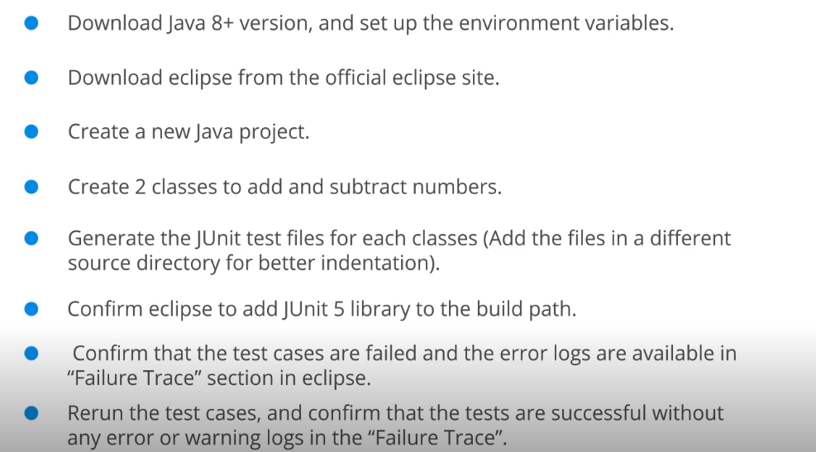

**5.6. Behavior-Driven Development Principles Cucumber and Its Applications**

Overview of Behavior-Driven Development:

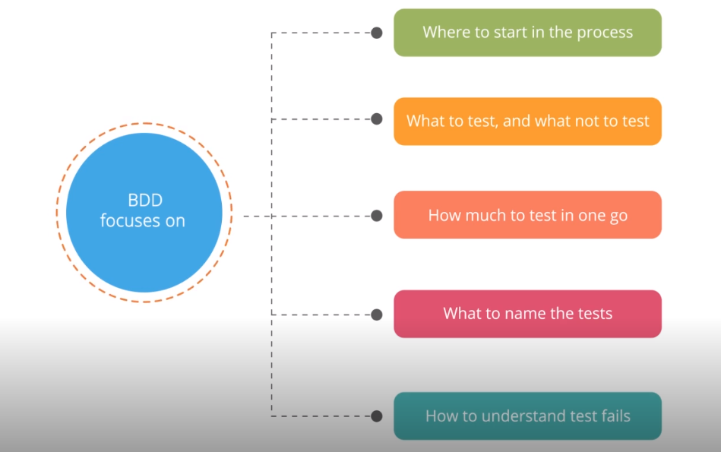

Behavior-Driven Development Principles:

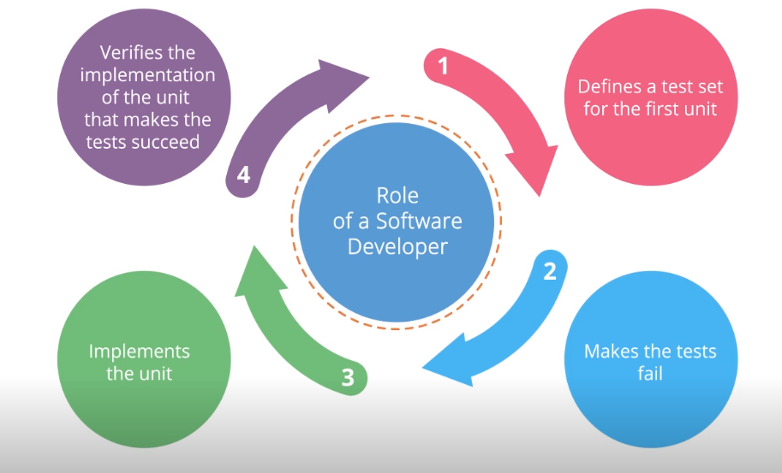

Overview of cucumber:

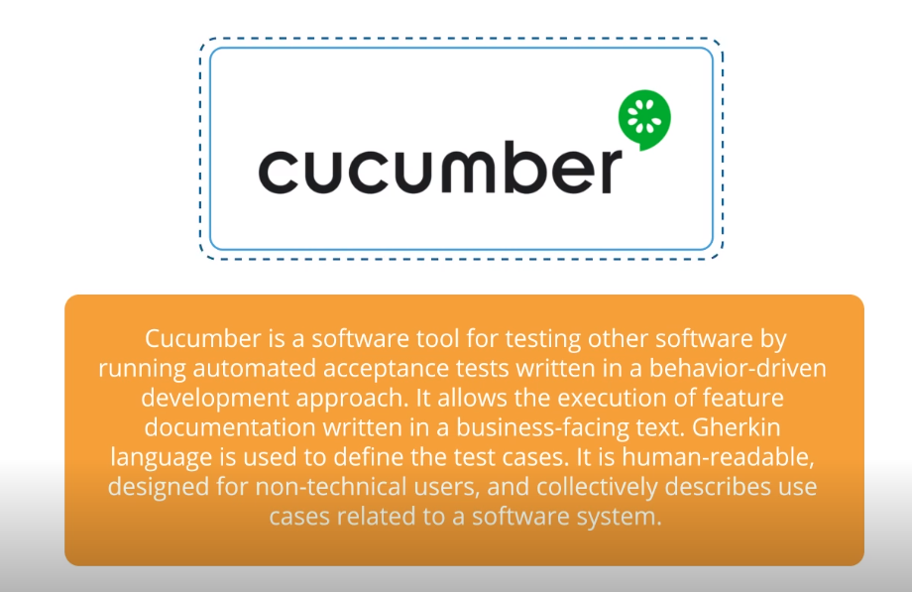

Gherkin: Language for cucumber:

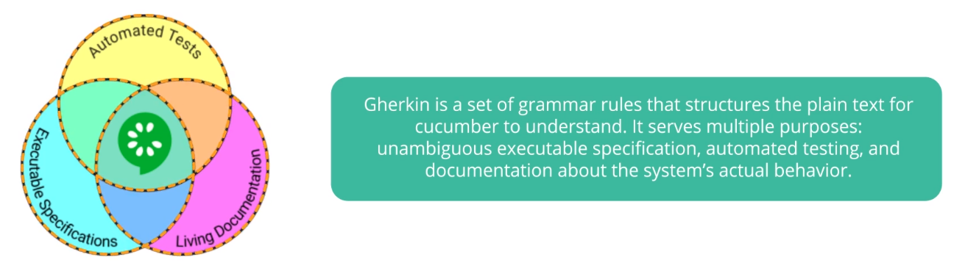

Gherkin Keywords:

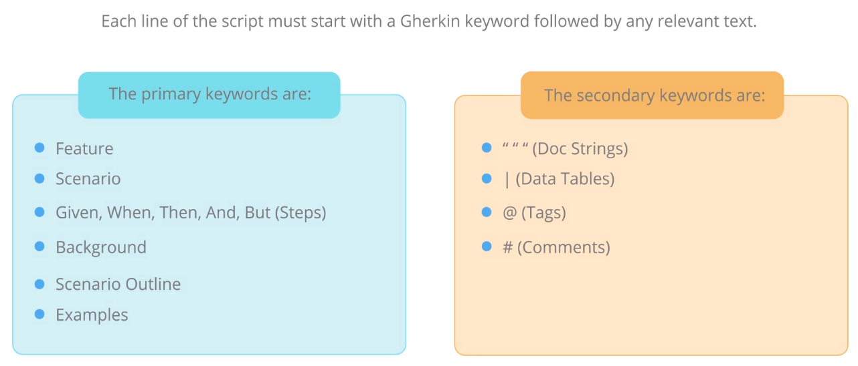

Tools for cucumber:

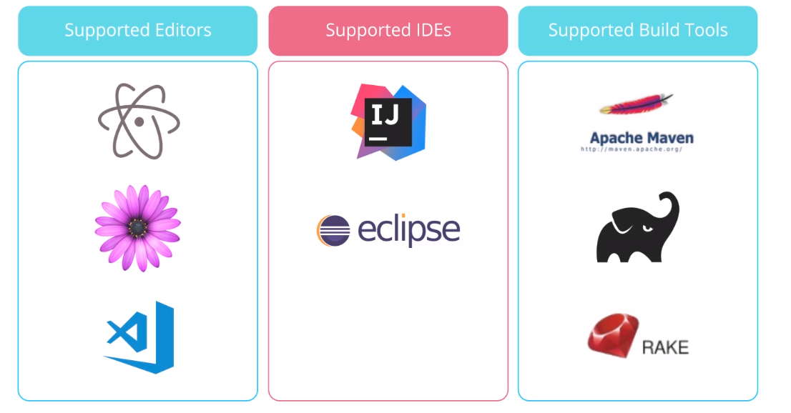

Cucumber with Java:

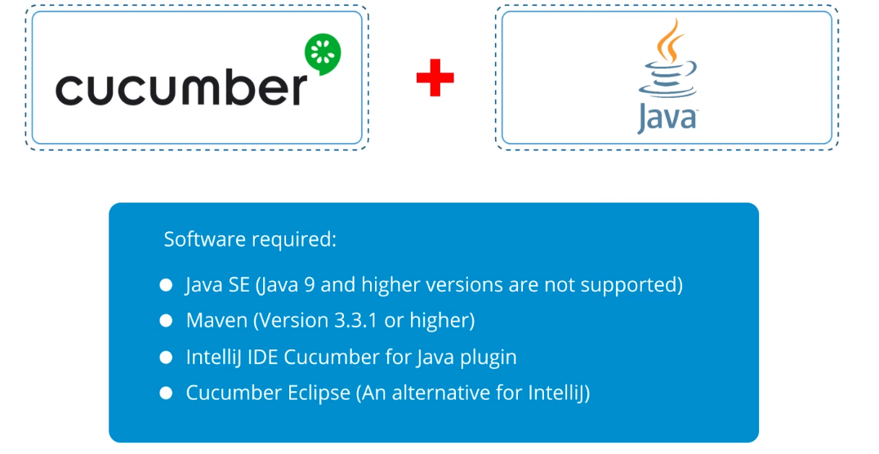

Cucumber with JavaScript:

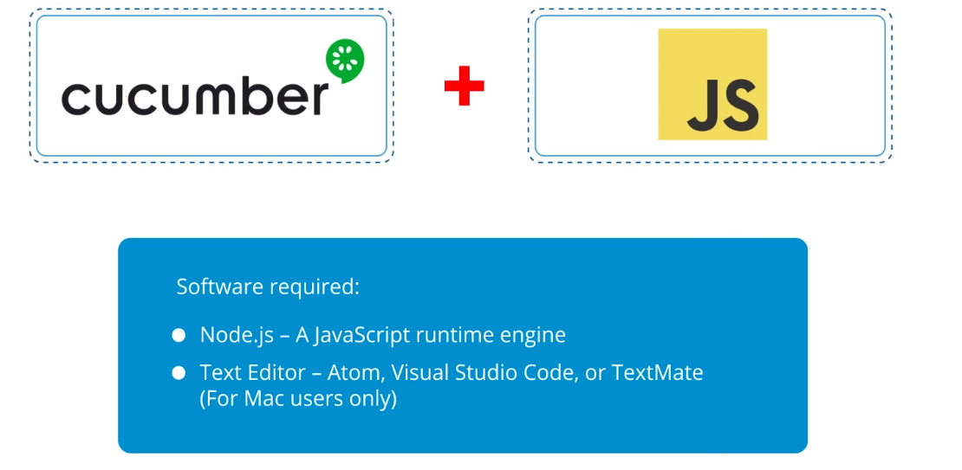

Cucumber with Ruby:

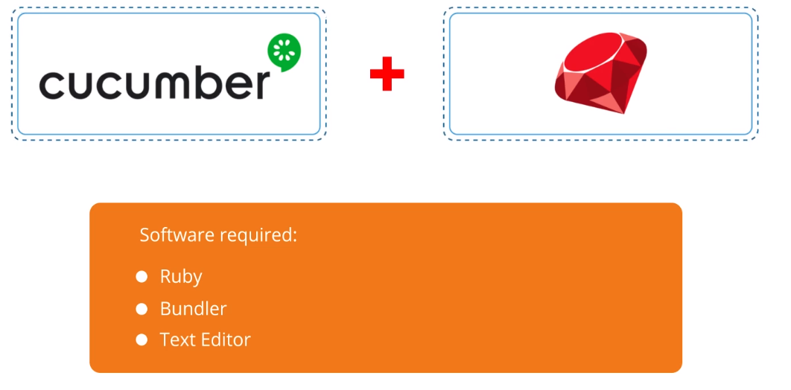

Cucumber with Kotlin:

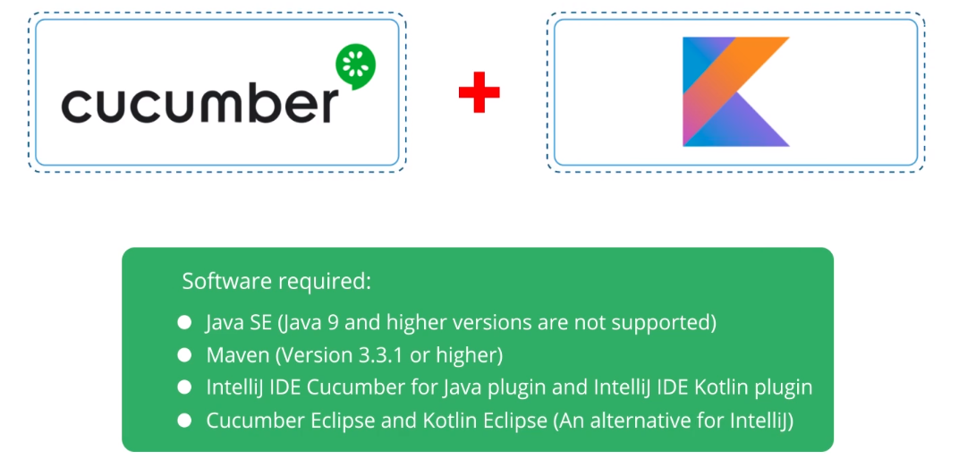

**5.7 Behavior-Driven Development Principles with Cucumber**

Praxisbeispiel:

